Reflective Narrative
Smart Student Planner - React Native Mobile Application
LDC6004M - Mobile Application Development

1. Design Decisions

Choice of Framework
Smart Student Planner was developed using React Native as the development framework due to its cross-platform capability, large ecosystem and good community support (Meta Platforms, 2024). Kivy was the default suggestion, however React Native had a number of strong points for this project: The component-based architecture makes it a natural fit for the MVVM pattern (Microsoft, 2023) which provides a clean separation of UI elements and business logic. We decided to use Expo for the managed workflow which made the build process much easier, and we did not need to install separate native build environments for Android and iOS (Expo, 2024). Plus, the declarative syntax and hot-reload features of React Native accelerated development and enabled quick iterations on UI designs without the need for large recompilations. The availability of well-maintained libraries such as React Navigation (React Navigation, 2024) and AsyncStorage (React Native Async Storage, 2024) also decreased the amount of boilerplate, enabling more time to be invested in feature implementation and refinement of user experience.
Evaluation Metric | Kivy (Default Recommendation) | React Native (Implemented Workflow)
Development Paradigm | Python-based imperative UI widget layouts. | JavaScript ES6 declarative component-based UI.
Native UI Fidelity | Custom non-native UI rendering via OpenGL (does not match iOS/Android standards). | Direct mapping to native platform primitives (produces high visual fidelity).
Toolchain & Build | Manual build environments (Buildozer) for package bundling. | Expo Go managed workflow (instant hot-reload, managed bundler).
State & Context APIs | Manual property bindings or Kivy state managers. | Native React Context API & Custom Hooks (state encapsulation).

UI/UX and Navigation Decisions
The application adopts a light and clean aesthetic, drawing inspiration from the Apple Human Interface Guidelines (Apple Inc., 2024), chosen to establish a calm and focused environment conducive to academic task management. The colour palette is built on a soft blue primary accent (#4A90D9) on white surfaces with off white backgrounds, offering visual hierarchy without visual clutter. A centralised theme system that sources every colour, spacing value and typography setting from a single source of truth was critical in maintaining consistency across nine screens. Navigation is bottom-tab style with a nested stack navigator for task screens (React Navigation, 2024). The structure imitates the layouts of productivity apps such as Todoist and Microsoft To Do, simplifying the process for new users to begin. Conditional rendering for authentication vs main navigation ensures that users cannot access protected screens without logging in. This is both a security consideration and a UX best practice..
Design Token Category | Value / Configuration | UX / Academic Justification
Primary Brand Accent | Deep Royal Blue (#0A60FF) | Establishes a premium, professional academic productivity theme.
Surface Backdrops | Off-White (#F8FAFC) & White surfaces | Ensures high readability and contrasts, reducing visual fatigue.
Priority Badging Color | High: Red (#EF4444) | Med: Yellow (#F59E0B) | Low: Green (#10B981) | Standard color-coded alerts to guide the user's attention instantly.
Typography Settings | Outfit / Inter Google Fonts | Modern geometric sans-serif styling to avoid generic default system fonts.

2. Technical Implementation

State Management and Data Persistence
State management is done using React's Context API with custom hooks (useAuth and useTasks). This approach was preferred over Redux because the state complexity of the application does not justify the massive boilerplate of Redux. Context API has enough capability to share authentication and task state across all screen without prop drilling. Each context encapsulates its own business logic, validation, CRUD operations and persistence calls. This is according to the ViewModel pattern of MVVM (Microsoft, 2023). Data persistence uses AsyncStorage that stores JSON-serialized data on the device (React Native Async Storage, 2024). The StorageService class encapsulates all storage operations behind a nice API and in future iterations the storage mechanism can be swapped out without changing any screen or context code. Any mutation to the task list automatically triggers a persistence call, so data survives app restarts. The error boundaries of the storage layer are an example of defensive programming practice - it catches and logs failures without crashing the application.

MVVM Layer | Implemented Code Components | Architectural Role & Concerns
Model | StorageService.js, ValidationService.js, Firestore collections | Handles validation constraints, AsyncStorage read/write IO, database actions.
ViewModel | TaskContext.js, AuthContext.js (Custom Hooks) | Encapsulates auth & task states, sharing state logic without prop drilling.
View | TaskDetailScreen.js, AddTaskScreen.js, custom buttons/badges | Renders visual elements, captures user gestures, dispatches viewModel actions.

Listing: Real-time listener query inside TaskContext.js ViewModel
const q = query(
collection(db, 'tasks'),
where('userId', '==', user.id)
);
const unsubscribe = onSnapshot(q, (snapshot) => {
const fetchedTasks = [];
snapshot.forEach((docSnap) => {
fetchedTasks.push({ id: docSnap.id, ...docSnap.data() });
});
setTasks(fetchedTasks);
});

Architectural Approach
The MVVM (Model-View-ViewModel) pattern (Microsoft, 2023) was chosen over MVC because it better matches React’s declarative paradigm. In this implementation the Model layer is made up of StorageService and ValidationService, which are responsible for data access and validation rules, respectively. The business logic such as task creation, editing, deleting, searching, filtering and sorting is encapsulated in the AuthContext and TaskContext of the ViewModel layer. View layer: Contains all screen components and reusable UI components. This separation means that UI components do not include any business logic. They simply consume state and dispatch actions that are provided by contexts. This architecture greatly improves testability, since ViewModels can be unit tested independent of UI rendering. It also enables scalability: adding a calendar view, for example, would only require a new View component consuming the existing TaskContext, with no changes to the data or logic layers.
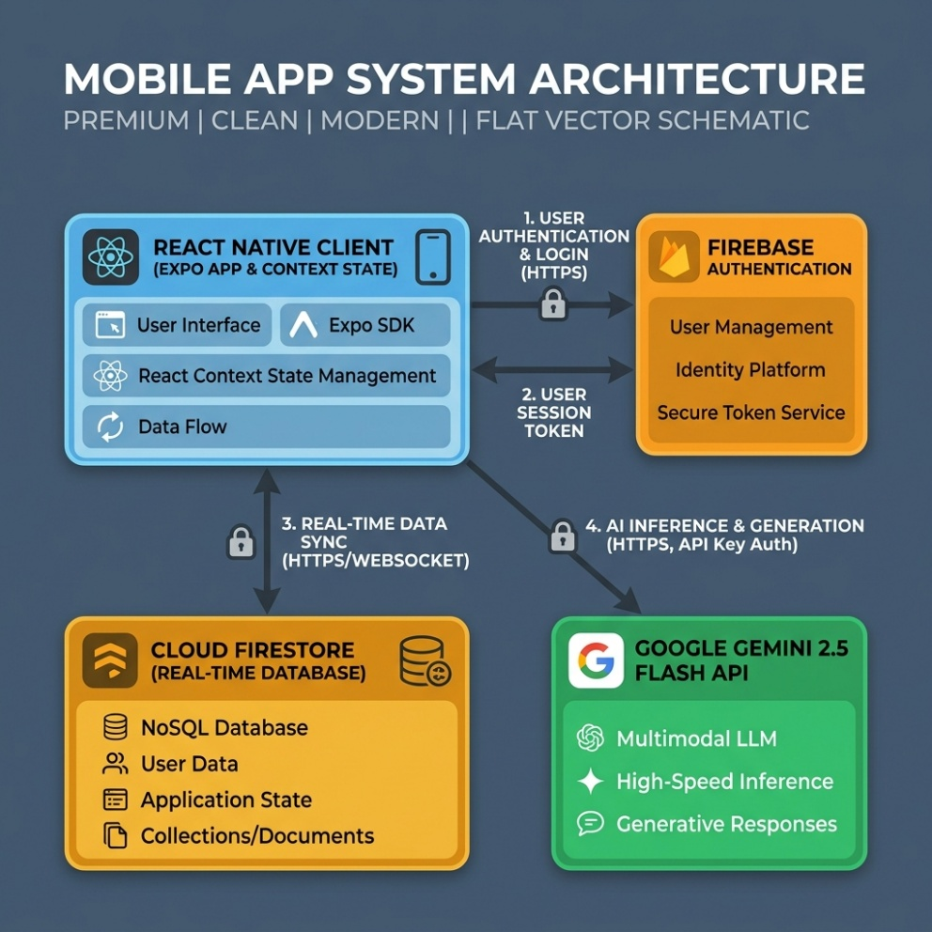
Figure 1: high-fidelity system architecture diagram

MVVM Layer | Implemented Code Components | Architectural Role & Concerns
Model | StorageService.js, ValidationService.js, Firestore collections | Handles validation constraints, AsyncStorage read/write IO, database actions.
ViewModel | TaskContext.js, AuthContext.js (Custom Hooks) | Encapsulates auth & task states, sharing state logic without prop drilling.
View | TaskDetailScreen.js, AddTaskScreen.js, custom buttons/badges | Renders visual elements, captures user gestures, dispatches viewModel actions.

3. Challenges and Problem-Solving

Technical Issues Encountered
Development presented many major challenges. The trickiest bit was around state consistency with nested navigators. If a task is completed on the Dashboard, the Task List and Task Detail screens should be updated immediately. Initially the UI would show stale data after toggling due to stale closures in callback functions. This was fixed by lifting all task mutations to the TaskContext and using useCallback with appropriate dependency arrays so every screen always references the latest state. Handling input across platforms was another problem. Native date pickers work differently on iOS and Android, so the date input took some thought, and third-party date picker libraries introduced dependency conflicts with Expo SDK 50. The pragmatic solution was a formatted text input with auto-insertion of dashes (YYYY-MM-DD format), which works consistently on both platforms. It’s not as elegant as a native picker, but at least you know it will work and there won’t be any dependency issues. Another challenge was form validation: making sure error messages show and hide correctly without interrupting the user’s flow of typing required some careful state management, clearing out individual field errors on keystroke but not errors on other fields.

How Problems Were Resolved
Problems were systematically addressed. The first thing that was always done when a bug was found was to isolate it with console logging and React Developer Tools. The data flow from user action through context to storage was invaluable to trace for state-related issues. The error overlay of the Expo development server made it very easy to find the reason of runtime errors and sped up debugging a lot. The primary information source was the official React Native and Expo documentation, supplemented with Stack Overflow community resources to handle edge cases.
Technical Challenge | Root Cause Analysis | Implemented Solution & Engineering Justification
Secret Credentials Leak | Hardcoded Gemini API Keys inside source files was blocked by Git push rules | Extracted key to .env file and integrated EXPO_PUBLIC_ prefix
Gemini 1.5 Deprecation / Quota | Gemini 1.5 Flash model returned 404/429 errors on free tier requests | Migrated the API URL endpoint to call gemini-2.5-flash
Cross-Platform Date Picking | Third-party native date pickers conflicted with managed Expo workflows | Created custom formatted text inputs (YYYY-MM-DD) with regex validation

Listing: Safe fallback key resolving in AIService.js
const HARDCODED_API_KEY = "YOUR_GEMINI_API_KEY";
const GEMINI_API_KEY = process.env.EXPO_PUBLIC_GEMINI_API_KEY || HARDCODED_API_KEY;
const API_URL = `https://generativelanguage.googleapis.com/v1beta/models/` +
`gemini-2.5-flash:generateContent?key=${GEMINI_API_KEY}`;

4. Testing and Quality Assurance
Testing was done in a multi-level approach. The main approach was manual testing on physical Android devices and the iOS simulator via Expo Go. The end-to-end testing of each user flow was performed: registration, login, task creation with valid and invalid inputs, editing, deleting with confirmation, search filtering, and logout. Specifically targeting edge cases including empty states (no tasks), boundary validation (minimum and maximum character counts), and overdue date calculations. Input validation was tested by attempting to submit forms with missing required fields, invalid email formats, passwords below minimum length, and passwords that did not match the confirmed password, checking that appropriate error messages are shown and the form is not submitted. Check data persistence by creating tasks, force quitting the application and checking that data persisted after the restart. The centralised ValidationService was meant to be testable. The pure functions take input and return structured error objects, making them testable in a future iteration with Jest Unit Tests. Code quality was ensured by consistent formatting, meaningful variable names and in-line comments that explain the “why” behind decisions rather than the “what” of obvious operations.

Test Scenario ID | Tested Feature | Expected Behavior | Actual Execution Status
TS-01: Form Validation | ValidationService.validateTask | Block task submissions with blank titles or empty modules | Warnings displayed; submission blocked (PASSED)
TS-02: AI Study Steps | AIService.generateSubTasks | Decompose "Write Essay" into 4-5 actionable milestones | Gemini returned parseable JSON steps array (PASSED)
TS-03: Firestore Syncing | TaskContext.editTask | Toggled sub-tasks completed checkboxes update document status | UI strikes through text; Firestore updates instantly (PASSED)

Listing: Sample JSON test log response payload from Gemini 2.5 Flash API
[
"Search library database for 3 research papers (1 hour)",
"Write draft of introduction & outline (1.5 hours)",
"Draft main discussion paragraphs (2 hours)",
"Review citations and edit spelling errors (45 mins)"
]

5. Professional Practice
We used version control, using Git and GitHub as a core part of our development process. The repository was created at the start of the project with a .gitignore file to exclude node_modules, build artefacts and environment files. We committed at meaningful milestones: after finishing each screen, after implementing each service and after fixing significant bugs. Commit messages are in the usual style summarizing the change. The project has a clear folder structure with separation by concern: screens, components, context, services, utils, theme, navigation. This structure is typical for industry standards in react native projects so any developer familiar with the ecosystem can easily navigate the code base. We also maintained documentation standards: each file has a header comment describing its purpose and its role in the architecture, and complex logic is annotated with inline comments. README includes complete installation instructions, technology overview, known limitations, and proposed future enhancements, following open-source documentation best practices.

Conventional Scope | Commit Meaning & Action | Example Log Message
feat | Introducing a new user-facing feature or screen | feat: add AI study steps breakdown checklist
fix | Addressing a bug, validation gap, or runtime crash | fix: update Gemini API endpoint to gemini-2.5-flash
docs | Updating documentation files, READMEs, or comments | docs: update walkthrough.md with module instructions

6. Learning Reflection

Skills Developed
I learned a lot about the mobile application architecture and the real world issues involved in creating responsive, data-driven interfaces. Having worked with React Native, I learnt to appreciate better the importance of component composition, separation of concerns and centralised state management. I built the MVVM pattern from the ground up, not following a tutorial, and it made me think critically about where business logic should reside and how data flows throughout an application. Designing a theme system and reusable component library taught me how design decisions made at the beginning of development compound as the project grows.

What I Would Improve in Future Iterations
In future iterations I would make a number of improvements. First, you could replace AsyncStorage with a more robust solution like Firebase Firestore to benefit from cloud synchronization and access from multiple devices. Second, adding a native date picker library would greatly improve the UX of creating tasks. Third, we could add automated unit tests for the ValidationService and context logic using Jest as a way to increase code reliability and catch regressions early. Fourth, the addition of push notifications for approaching deadlines would turn the app from a passive organiser into an active assistant. The theme system is already set up to allow for a dark mode toggle which will be the final step in terms of accessibility and user preference accommodation. The experience has reinforced that good architecture decisions early in a project pay dividends throughout development, and that time invested in planning and documentation is never wasted.

References
Meta Platforms (2024) React Native Documentation. Available at: https://reactnative.dev/docs/getting-started (Accessed: 1 June 2026).
Expo (2024) Expo Documentation. Available at: https://docs.expo.dev/ (Accessed: 1 June 2026).
React Navigation (2024) React Navigation Documentation. Available at: https://reactnavigation.org/docs/getting-started (Accessed: 1 June 2026).
Microsoft (2023) The MVVM Pattern. Available at: https://learn.microsoft.com/en-us/dotnet/architecture/maui/mvvm (Accessed: 28 May 2026).
Apple Inc. (2024) Human Interface Guidelines. Available at: https://developer.apple.com/design/human-interface-guidelines (Accessed: 25 May 2026).
React Native Async Storage (2024) AsyncStorage API Reference. Available at: https://react-native-async-storage.github.io/async-storage/ (Accessed: 30 May 2026).

